Test Case: runTestMultipleTimes
Step 1 - Enter username and password and click to button Enter : Credentials Entered
Image file-name: QC_Testing-runTestMultipleTimes-nov. 28 2025, 09 58 19 a. m.

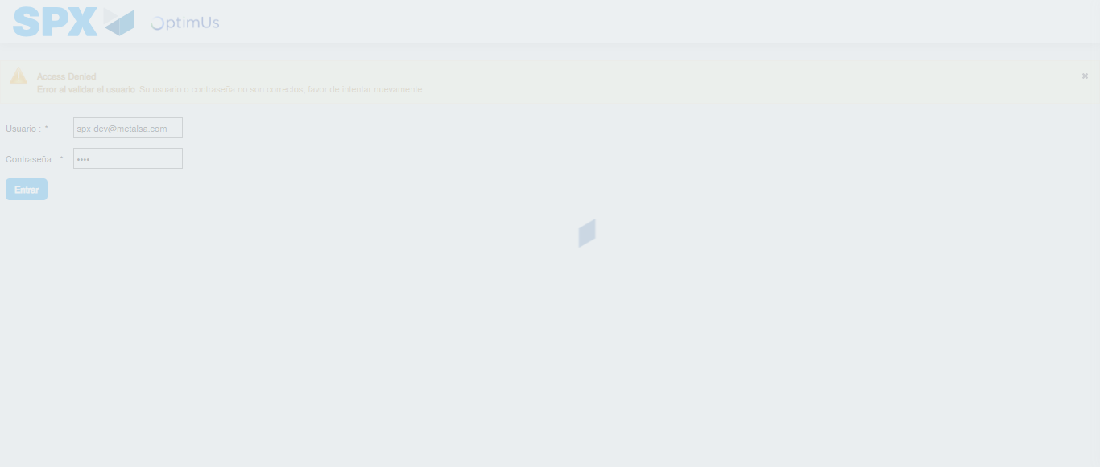Image file-name: QC_Testing-runTestMultipleTimes-nov. 28 2025, 09 58 20 a. m.

Step 2 - Select to UEN and Access to Spot Buy Requisitions : UEN Correctly selected and Correct access
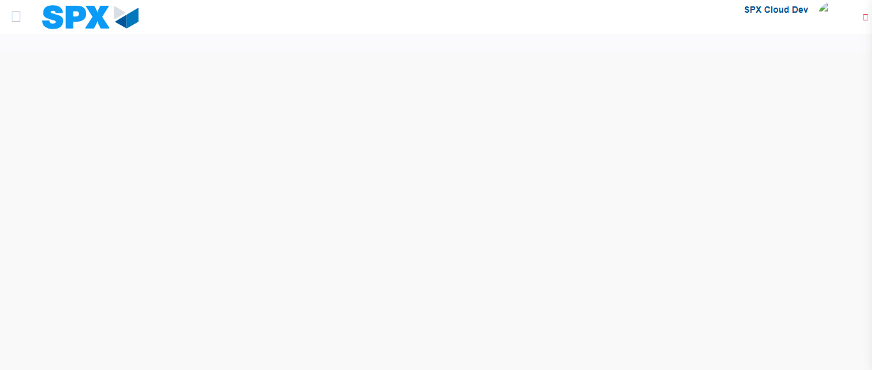Image file-name: QC_Testing-runTestMultipleTimes-nov. 28 2025, 09 58 26 a. m.

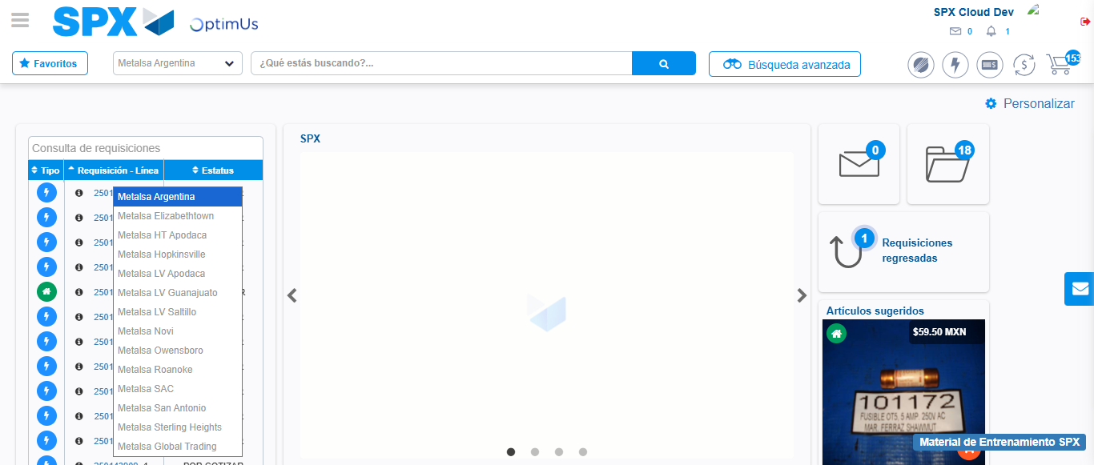Image file-name: QC_Testing-runTestMultipleTimes-nov. 28 2025, 09 58 27 a. m.

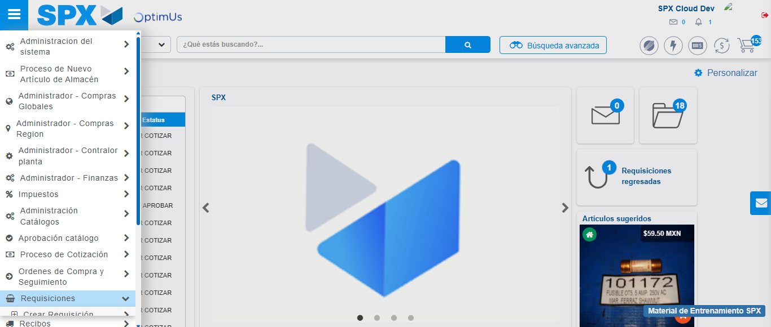Image file-name: QC_Testing-runTestMultipleTimes-nov. 28 2025, 09 58 28 a. m.

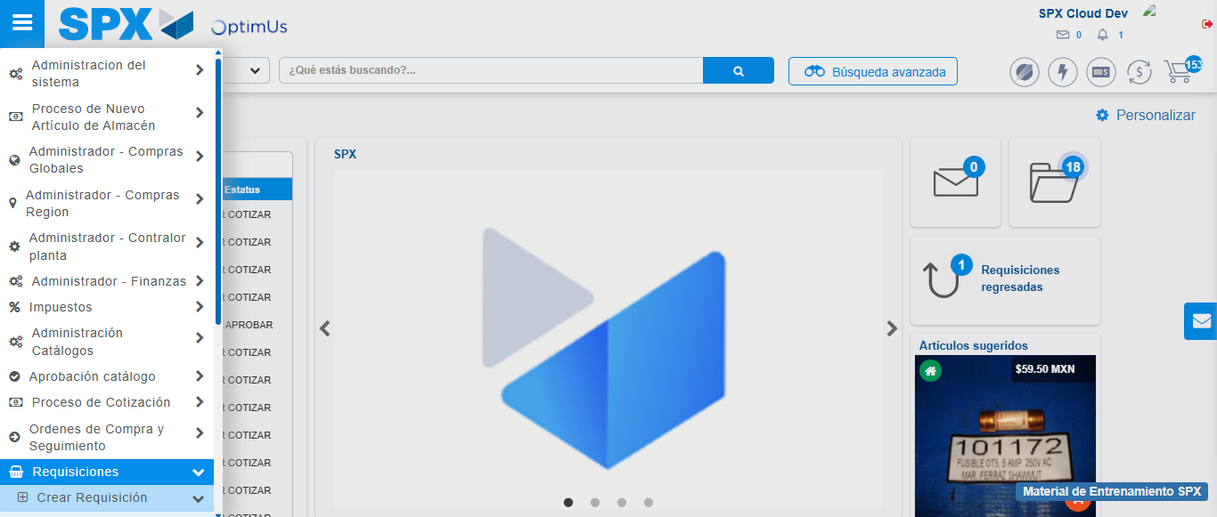Image file-name: QC_Testing-runTestMultipleTimes-nov. 28 2025, 09 58 29 a. m.

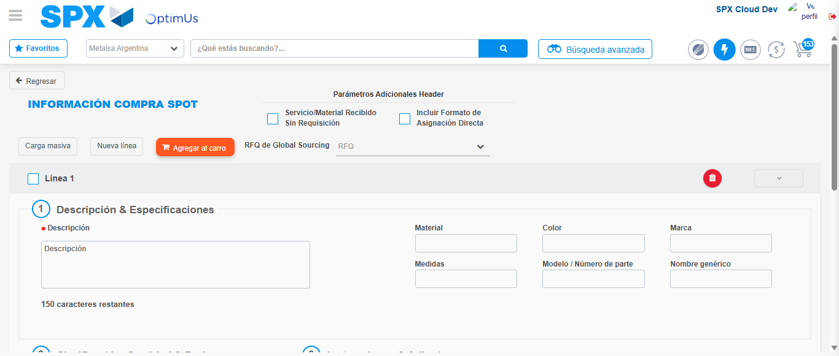Image file-name: QC_Testing-runTestMultipleTimes-nov. 28 2025, 09 58 32 a. m.

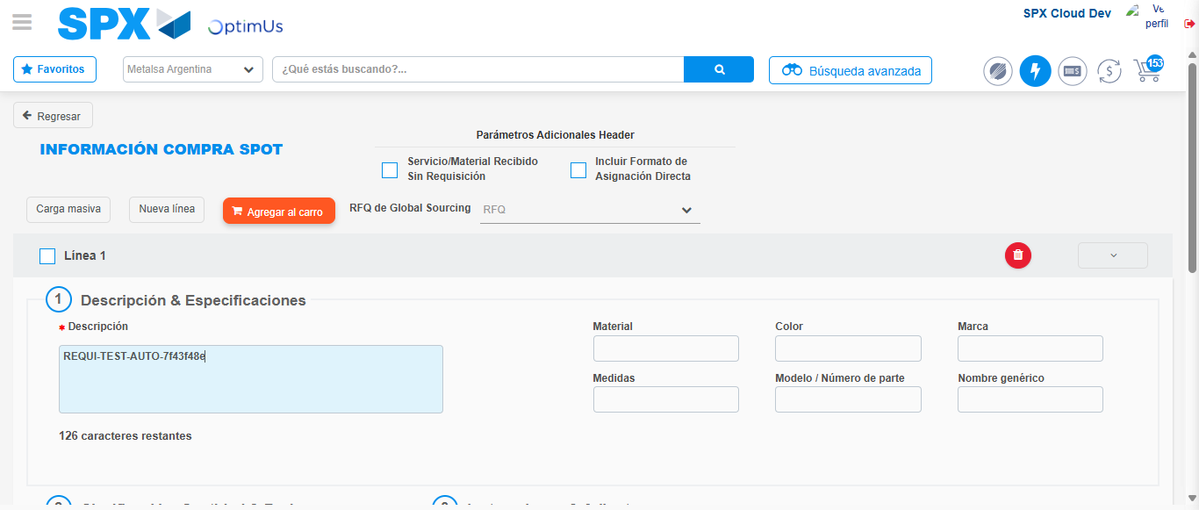Image file-name: QC_Testing-runTestMultipleTimes-nov. 28 2025, 09 58 33 a. m.

Step 3 - Data Capture Spot Buy Requisition: Data captured correctly
Image file-name: QC_Testing-runTestMultipleTimes-nov. 28 2025, 09 58 33 a. m.

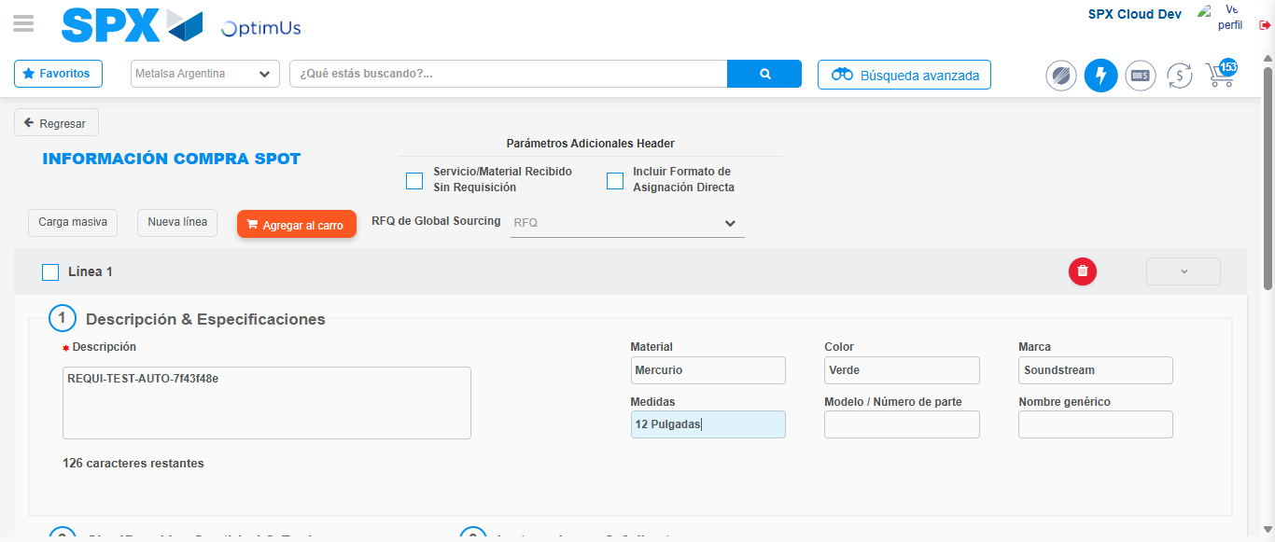Image file-name: QC_Testing-runTestMultipleTimes-nov. 28 2025, 09 58 34 a. m.

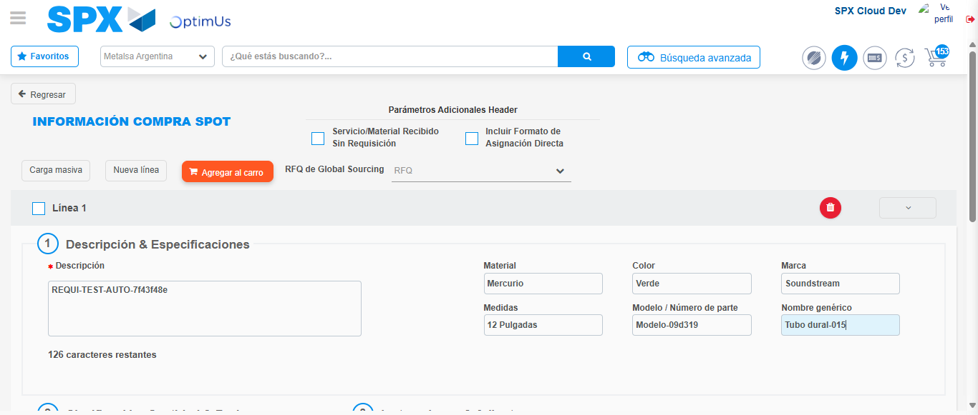Image file-name: QC_Testing-runTestMultipleTimes-nov. 28 2025, 09 58 35 a. m.

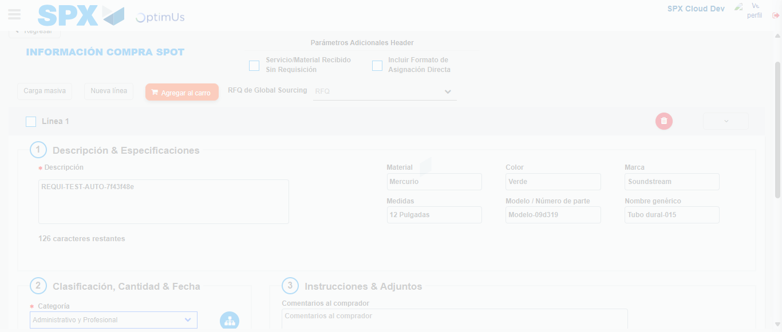Image file-name: QC_Testing-runTestMultipleTimes-nov. 28 2025, 09 58 36 a. m.

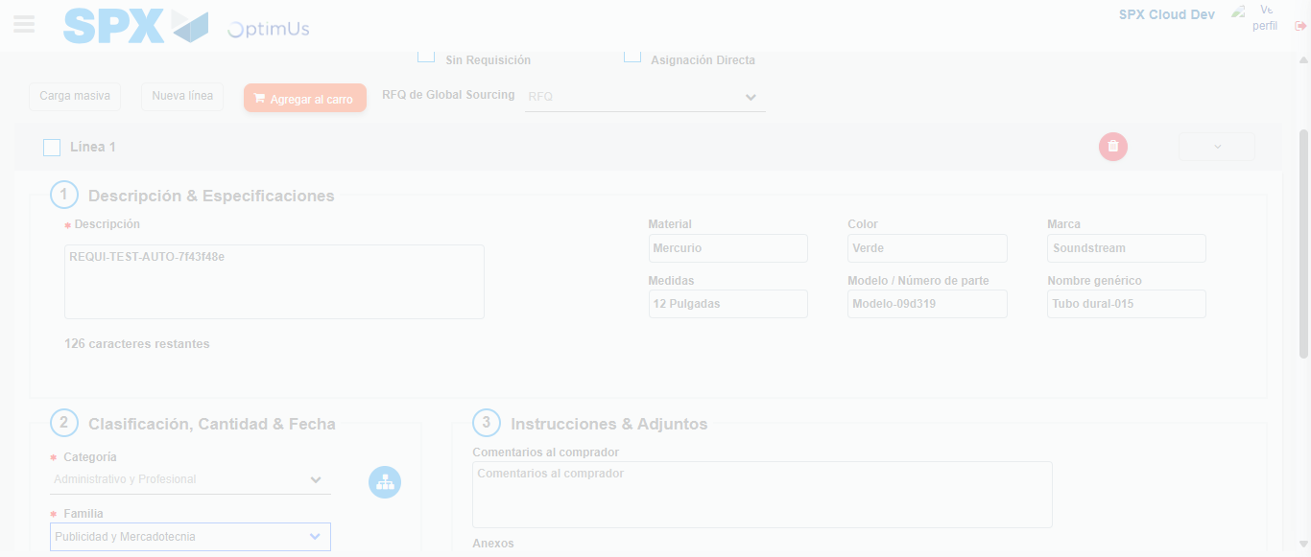Image file-name: QC_Testing-runTestMultipleTimes-nov. 28 2025, 09 58 37 a. m.

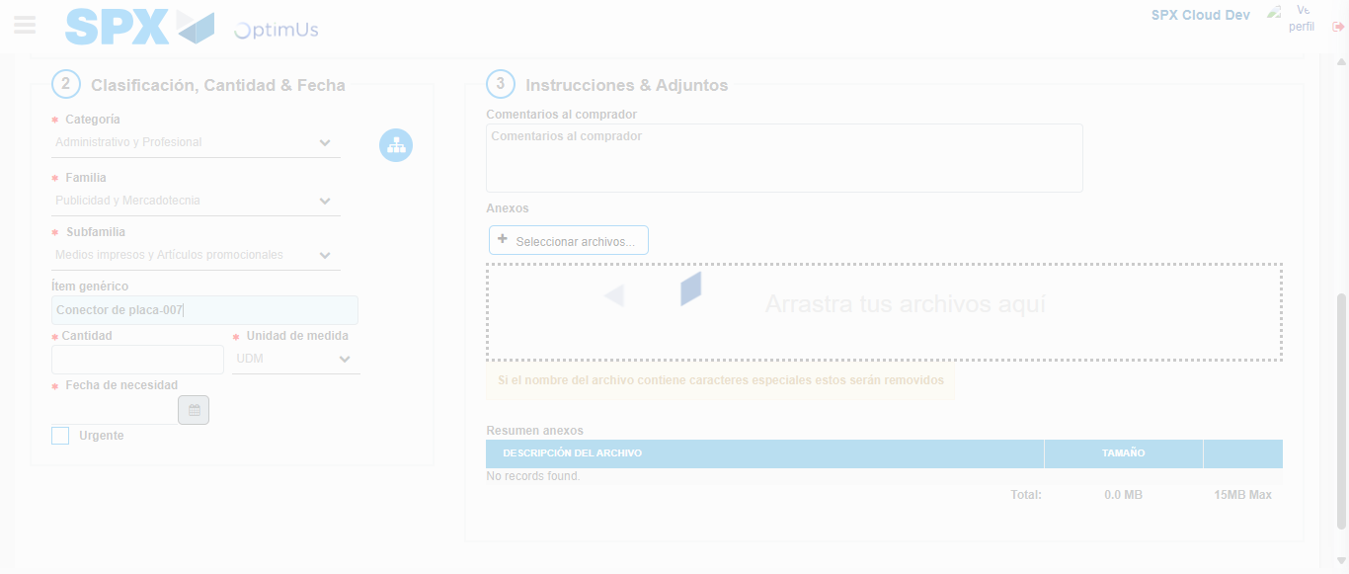Image file-name: QC_Testing-runTestMultipleTimes-nov. 28 2025, 09 58 38 a. m.

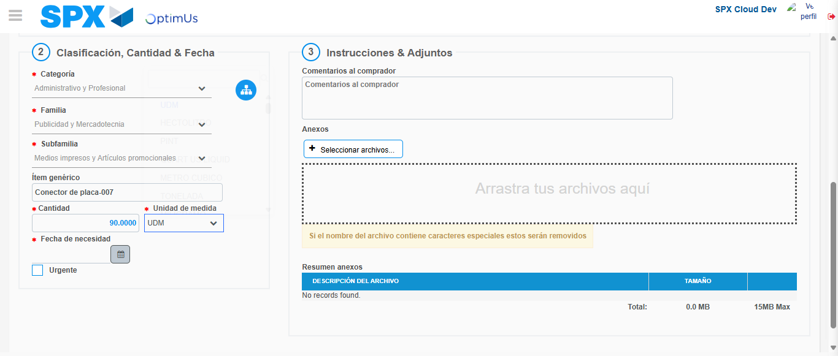Image file-name: QC_Testing-runTestMultipleTimes-nov. 28 2025, 09 58 39 a. m.

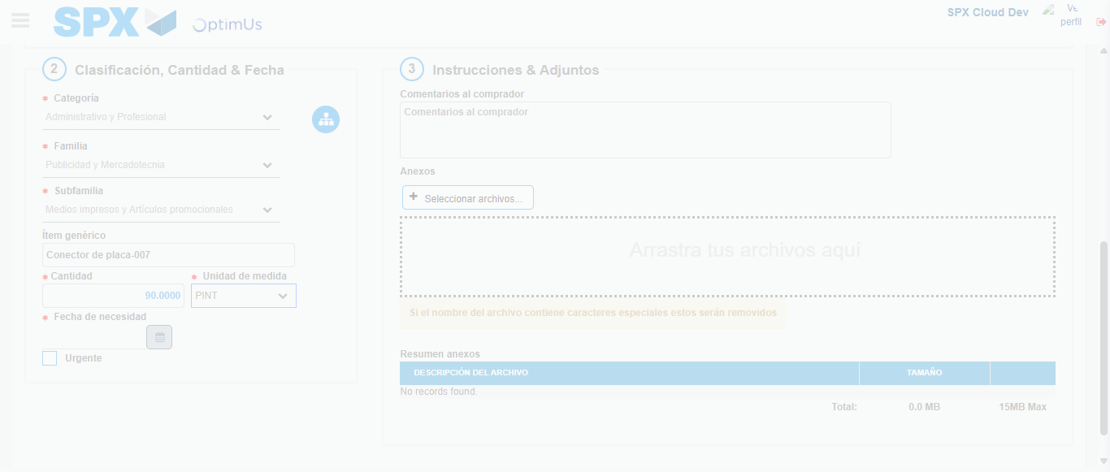Image file-name: QC_Testing-runTestMultipleTimes-nov. 28 2025, 09 58 40 a. m.

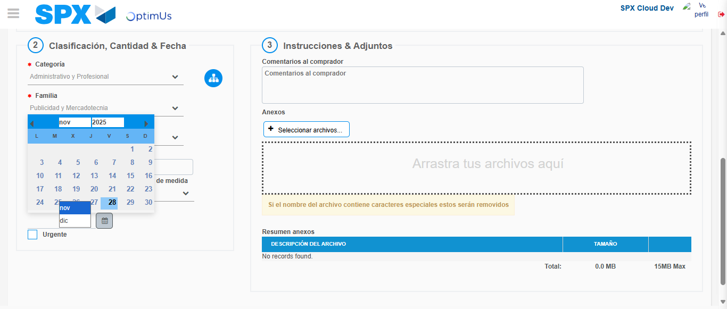Image file-name: QC_Testing-runTestMultipleTimes-nov. 28 2025, 09 58 41 a. m.

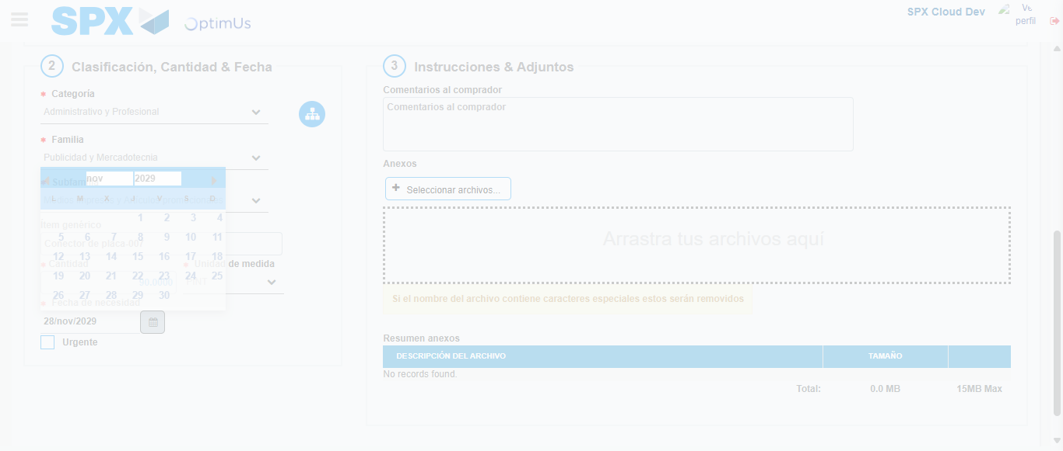Image file-name: QC_Testing-runTestMultipleTimes-nov. 28 2025, 09 58 42 a. m.

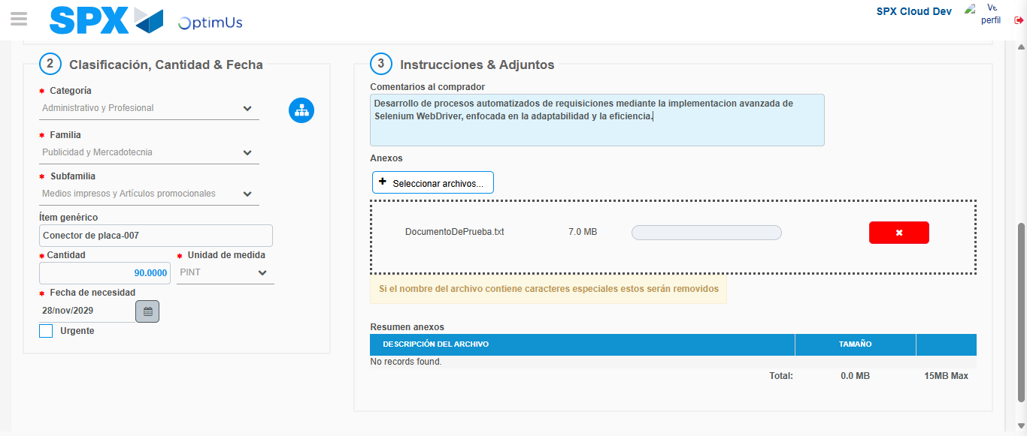Image file-name: QC_Testing-runTestMultipleTimes-nov. 28 2025, 09 58 43 a. m.

Step 4 - Add new line and data capture second line: Line add correctly
Image file-name: QC_Testing-runTestMultipleTimes-nov. 28 2025, 09 58 33 a. m.

Image file-name: QC_Testing-runTestMultipleTimes-nov. 28 2025, 09 58 34 a. m.

Image file-name: QC_Testing-runTestMultipleTimes-nov. 28 2025, 09 58 35 a. m.

Image file-name: QC_Testing-runTestMultipleTimes-nov. 28 2025, 09 58 36 a. m.

Image file-name: QC_Testing-runTestMultipleTimes-nov. 28 2025, 09 58 37 a. m.

Image file-name: QC_Testing-runTestMultipleTimes-nov. 28 2025, 09 58 38 a. m.

Image file-name: QC_Testing-runTestMultipleTimes-nov. 28 2025, 09 58 39 a. m.

Image file-name: QC_Testing-runTestMultipleTimes-nov. 28 2025, 09 58 40 a. m.

Image file-name: QC_Testing-runTestMultipleTimes-nov. 28 2025, 09 58 41 a. m.

Image file-name: QC_Testing-runTestMultipleTimes-nov. 28 2025, 09 58 42 a. m.

Image file-name: QC_Testing-runTestMultipleTimes-nov. 28 2025, 09 58 43 a. m.

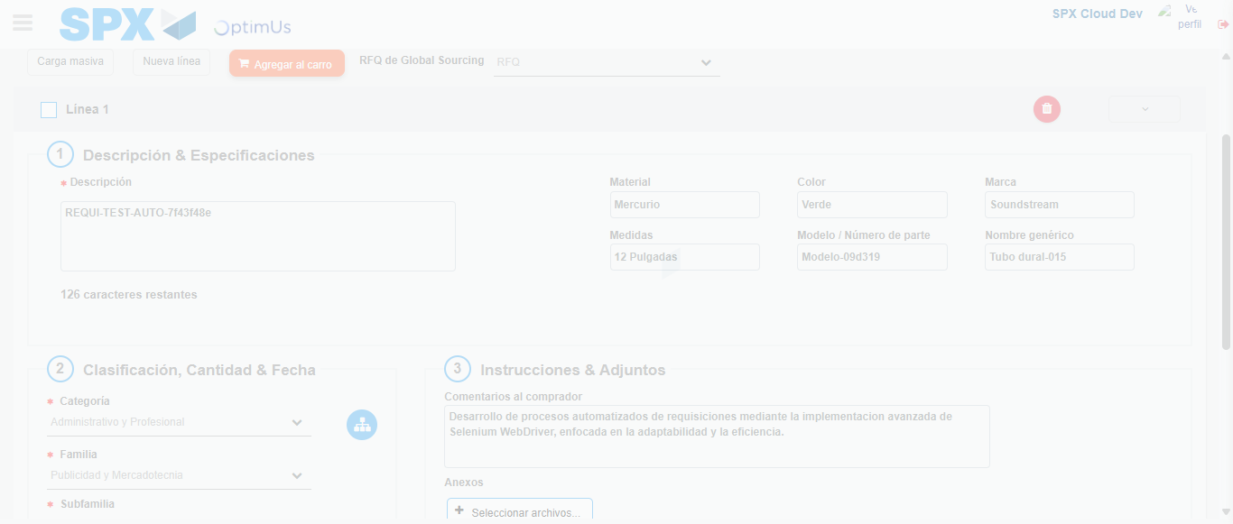Image file-name: QC_Testing-runTestMultipleTimes-nov. 28 2025, 09 58 44 a. m.

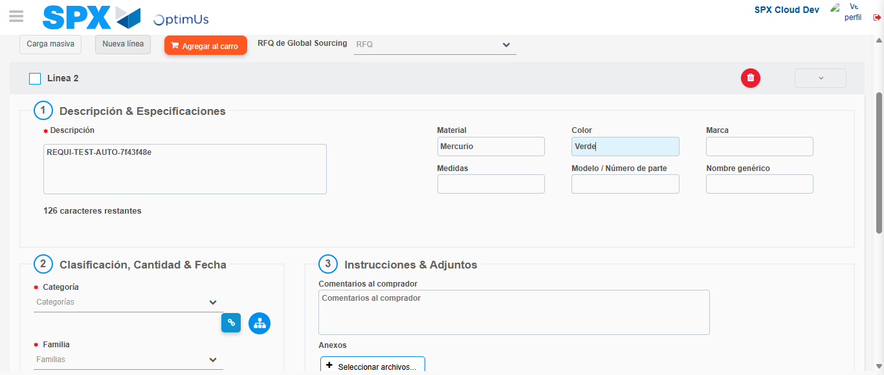Image file-name: QC_Testing-runTestMultipleTimes-nov. 28 2025, 09 58 47 a. m.

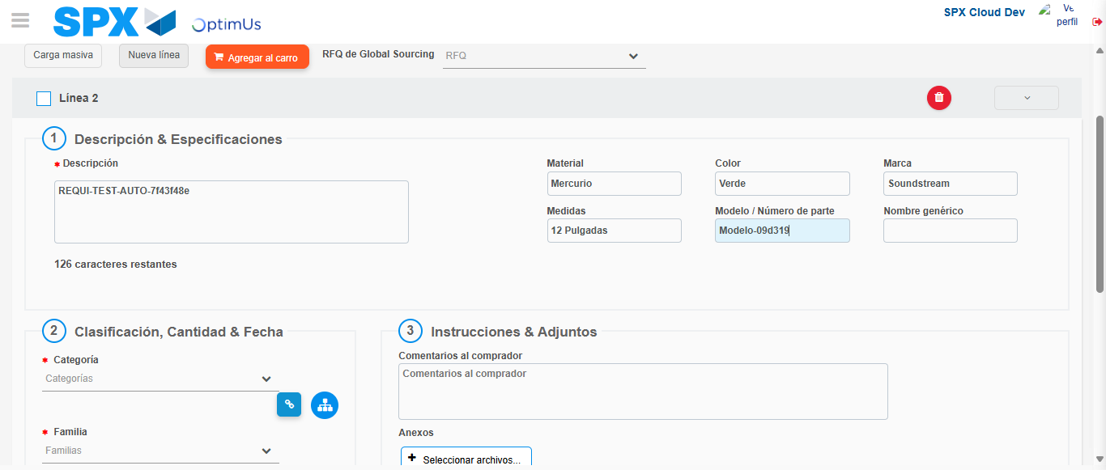Image file-name: QC_Testing-runTestMultipleTimes-nov. 28 2025, 09 58 48 a. m.

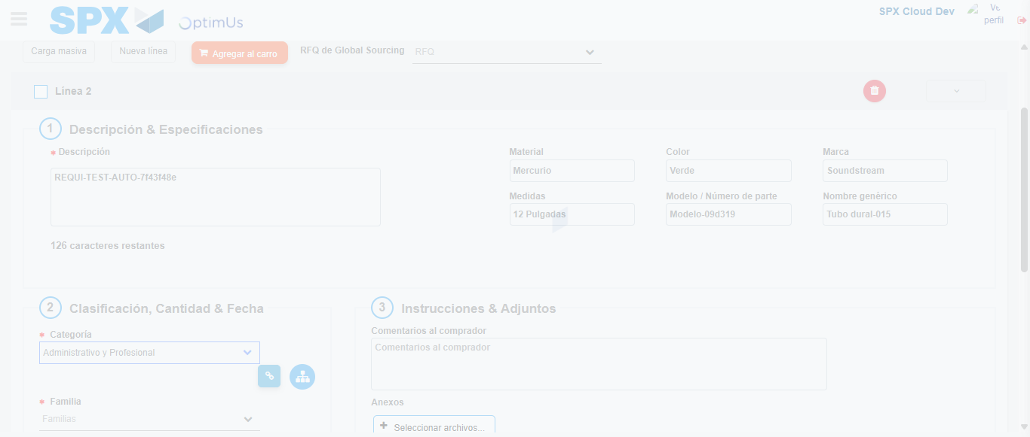Image file-name: QC_Testing-runTestMultipleTimes-nov. 28 2025, 09 58 49 a. m.

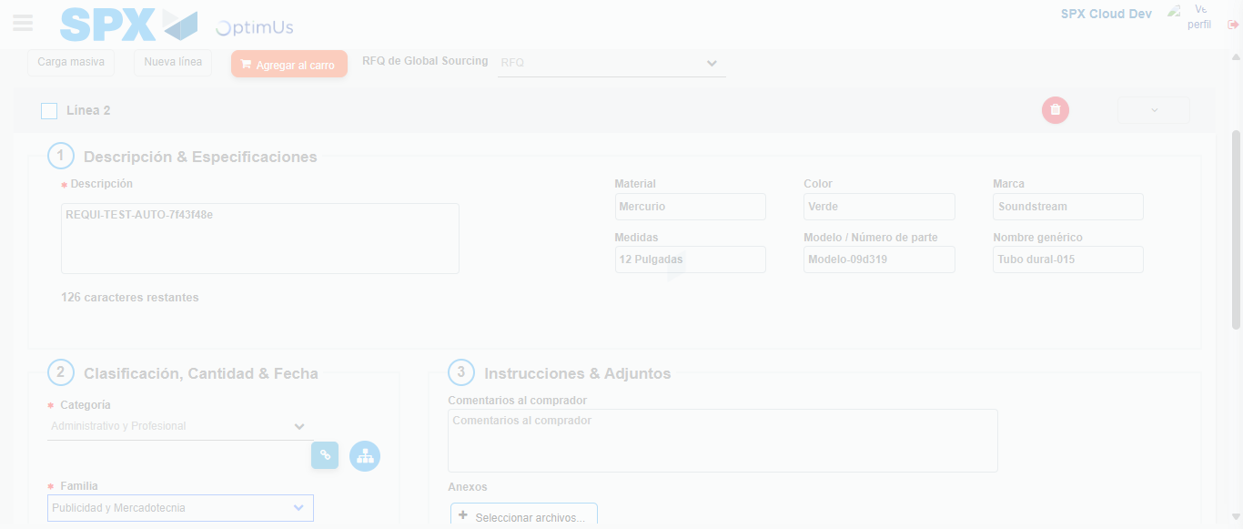Image file-name: QC_Testing-runTestMultipleTimes-nov. 28 2025, 09 58 50 a. m.

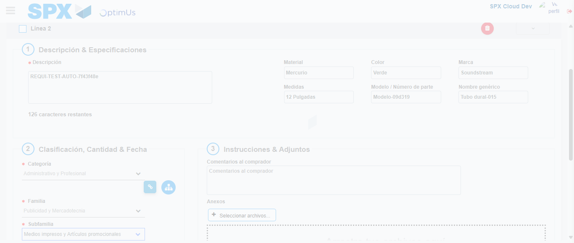Image file-name: QC_Testing-runTestMultipleTimes-nov. 28 2025, 09 58 51 a. m.

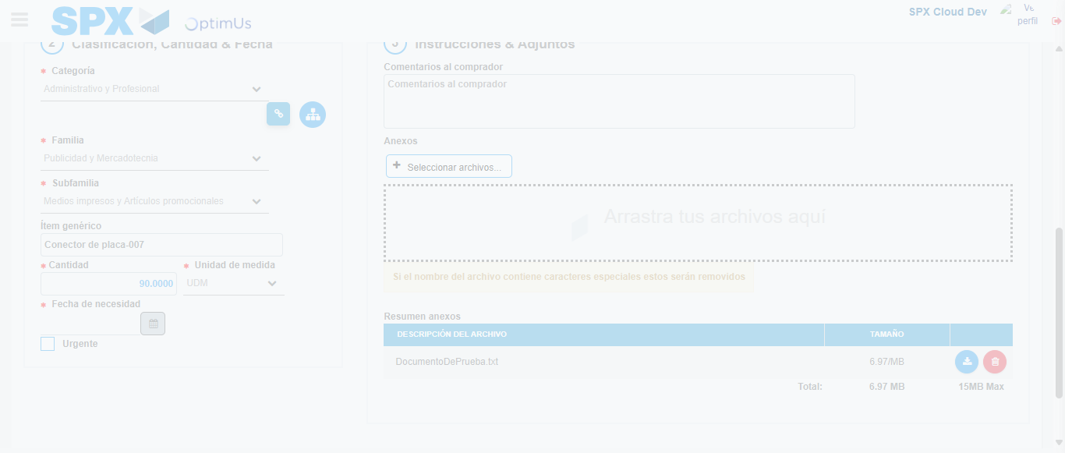Image file-name: QC_Testing-runTestMultipleTimes-nov. 28 2025, 09 58 52 a. m.

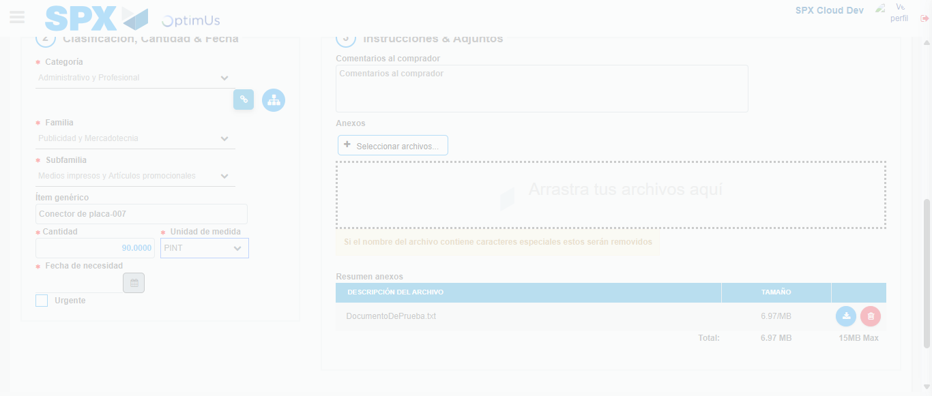Image file-name: QC_Testing-runTestMultipleTimes-nov. 28 2025, 09 58 53 a. m.

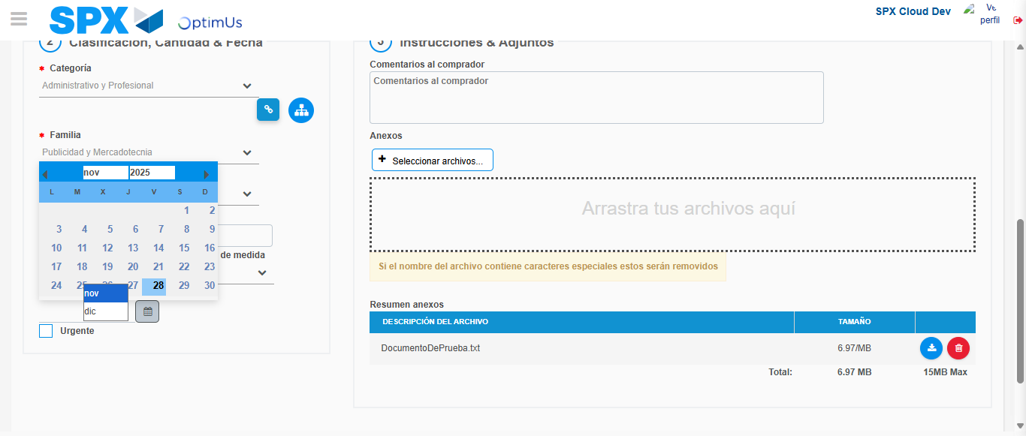Image file-name: QC_Testing-runTestMultipleTimes-nov. 28 2025, 09 58 54 a. m.

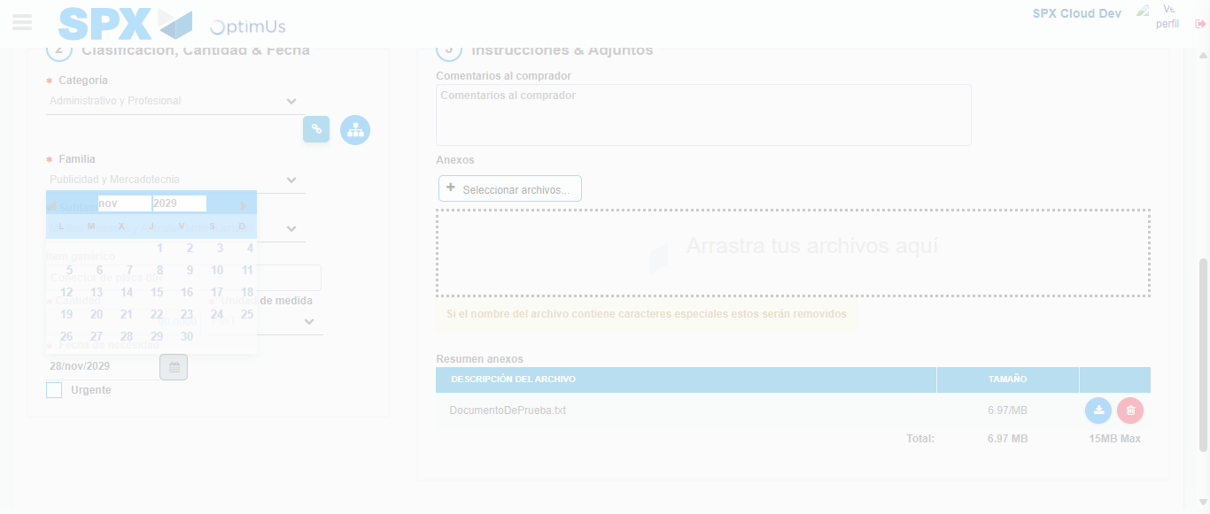Image file-name: QC_Testing-runTestMultipleTimes-nov. 28 2025, 09 58 55 a. m.

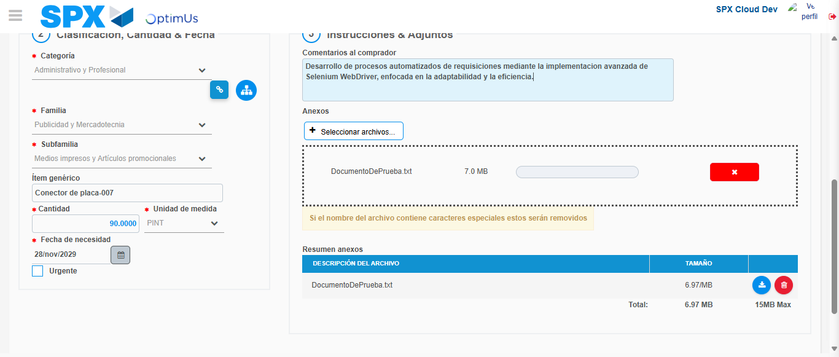Image file-name: QC_Testing-runTestMultipleTimes-nov. 28 2025, 09 58 56 a. m.

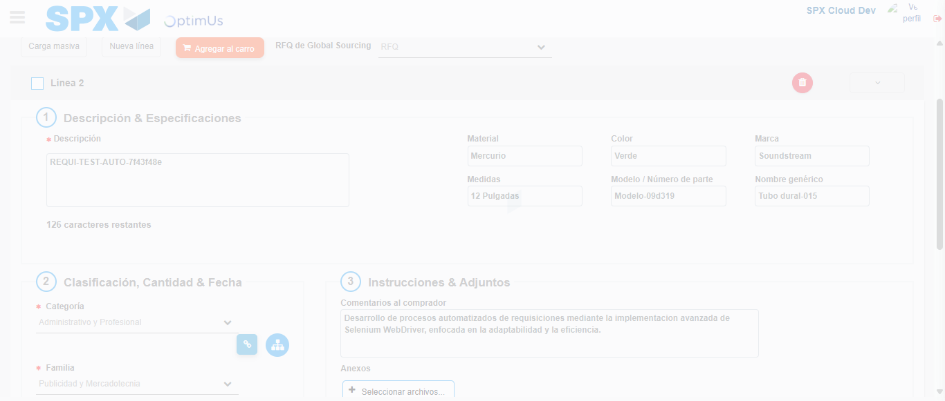Image file-name: QC_Testing-runTestMultipleTimes-nov. 28 2025, 09 58 57 a. m.

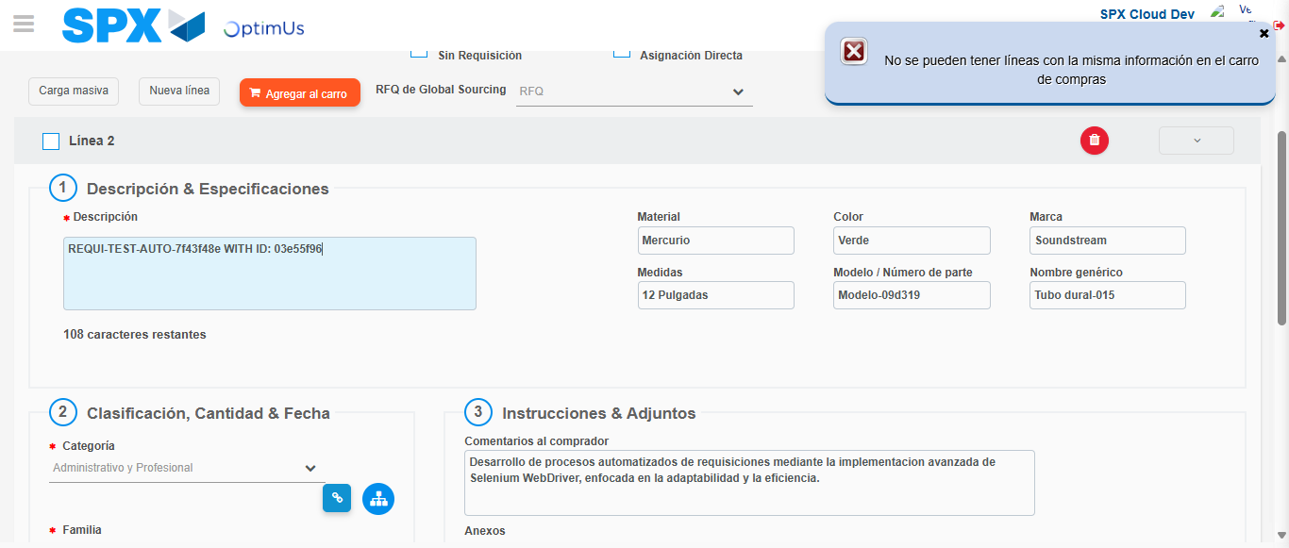Image file-name: QC_Testing-runTestMultipleTimes-nov. 28 2025, 09 58 58 a. m.

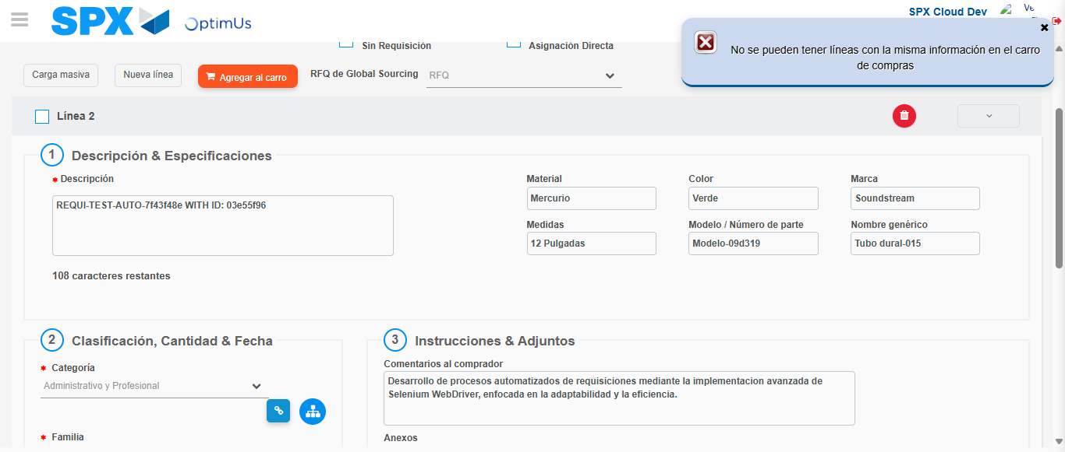Image file-name: QC_Testing-runTestMultipleTimes-nov. 28 2025, 09 58 59 a. m.

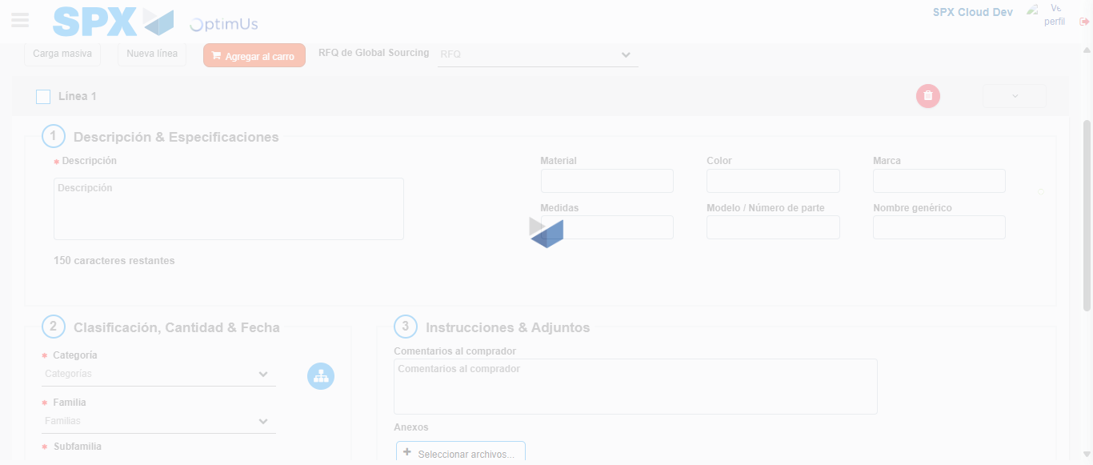Image file-name: QC_Testing-runTestMultipleTimes-nov. 28 2025, 09 59 06 a. m.

Step 5 - Select to Requisition: Requisition Correctly selected
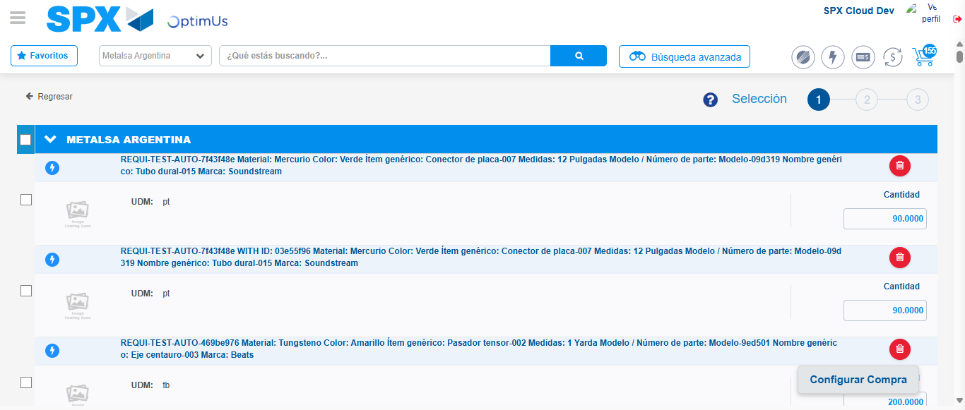Image file-name: QC_Testing-runTestMultipleTimes-nov. 28 2025, 09 59 15 a. m.

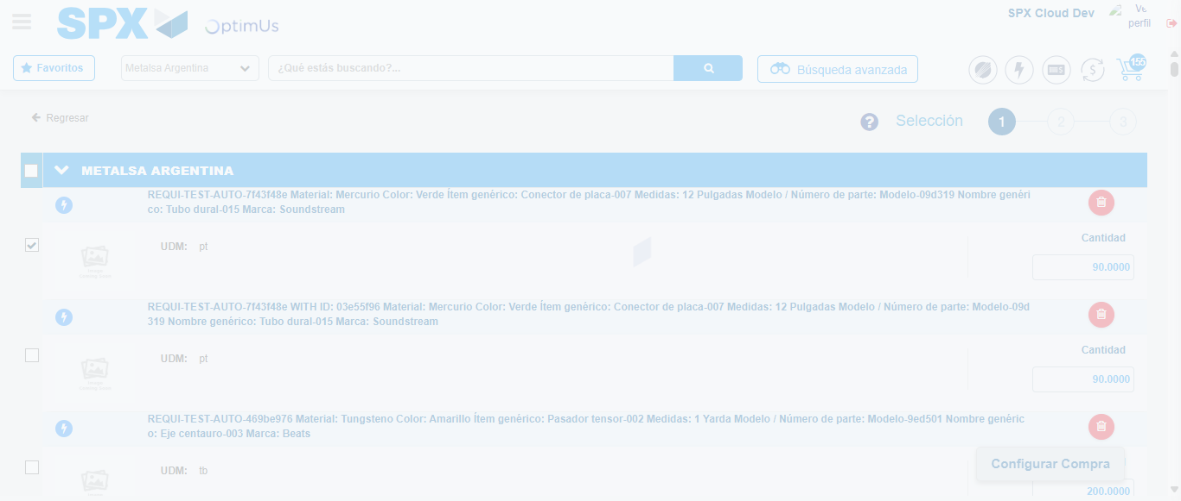Image file-name: QC_Testing-runTestMultipleTimes-nov. 28 2025, 09 59 16 a. m.

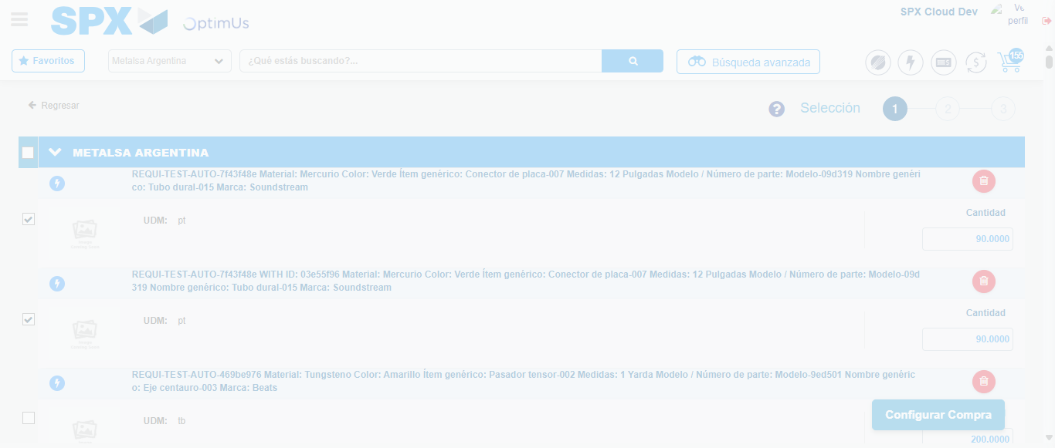Image file-name: QC_Testing-runTestMultipleTimes-nov. 28 2025, 09 59 17 a. m.

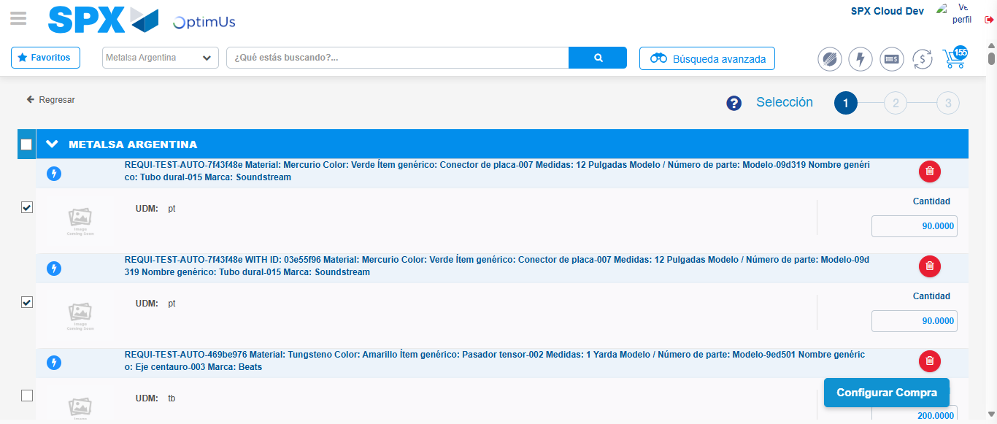Image file-name: QC_Testing-runTestMultipleTimes-nov. 28 2025, 09 59 20 a. m.

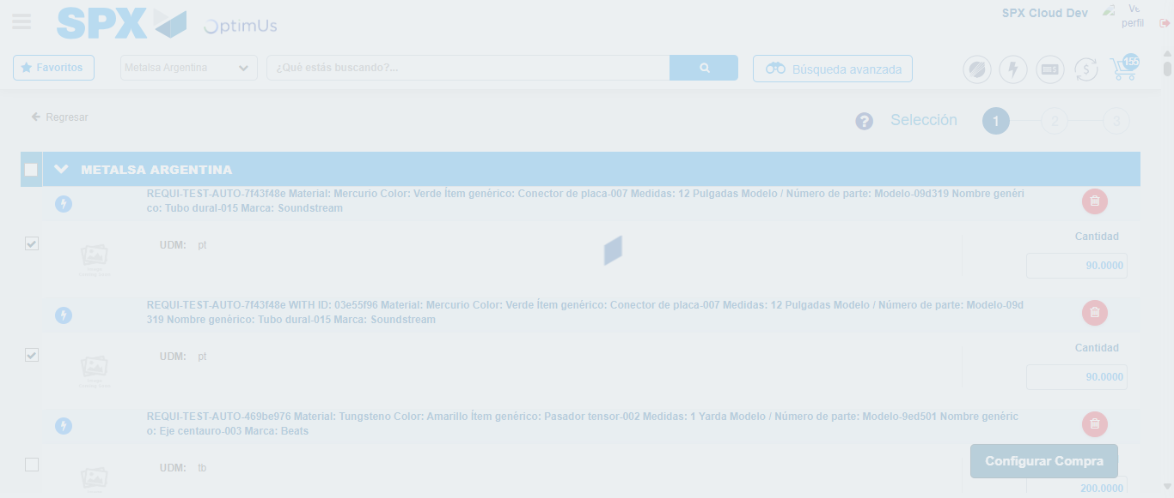Image file-name: QC_Testing-runTestMultipleTimes-nov. 28 2025, 09 59 21 a. m.

Step 6 - Select Type Account For Requisition: Type Account Correctly selected
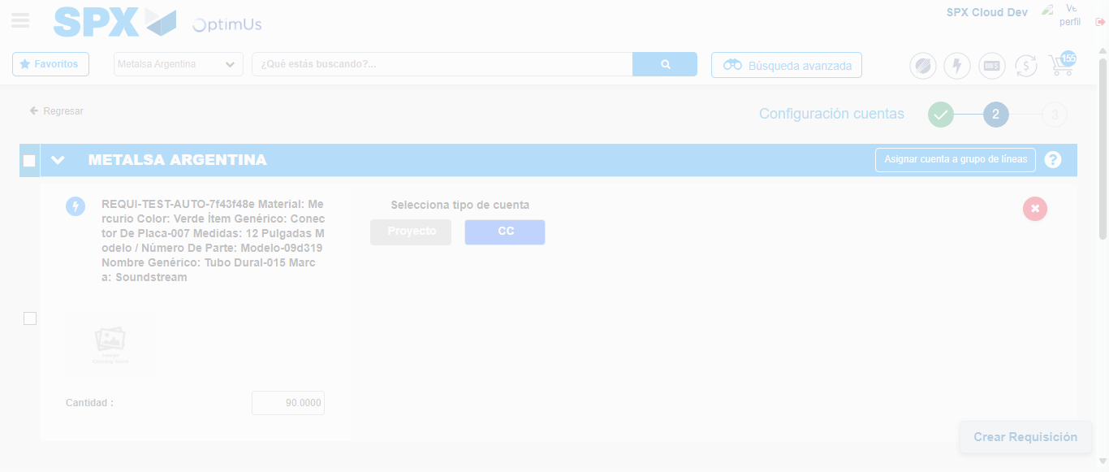Image file-name: QC_Testing-runTestMultipleTimes-nov. 28 2025, 09 59 23 a. m.

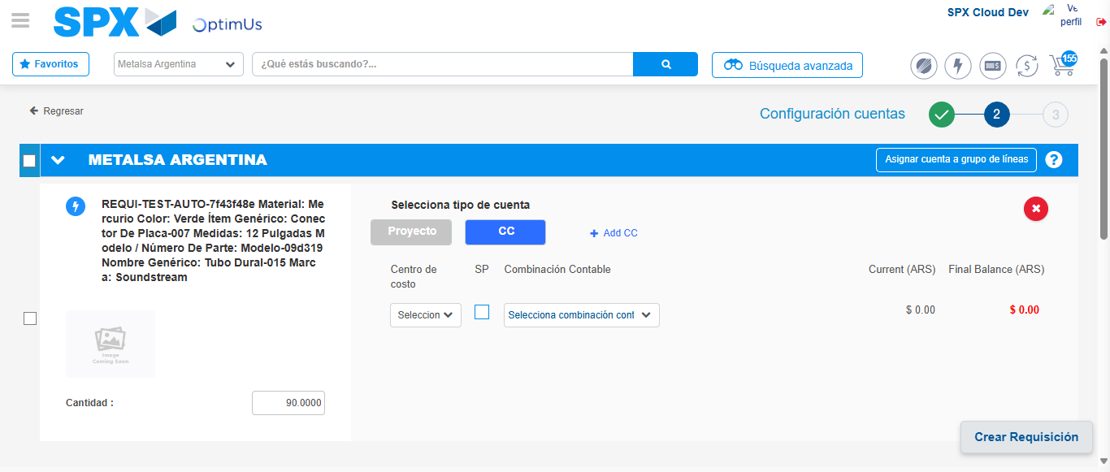Image file-name: QC_Testing-runTestMultipleTimes-nov. 28 2025, 09 59 27 a. m.

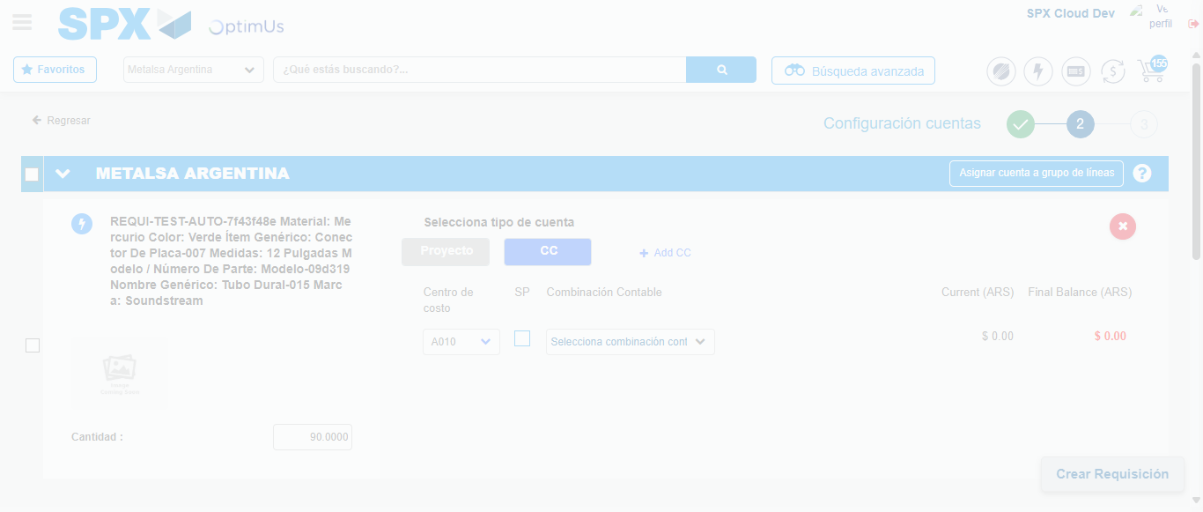Image file-name: QC_Testing-runTestMultipleTimes-nov. 28 2025, 09 59 30 a. m.

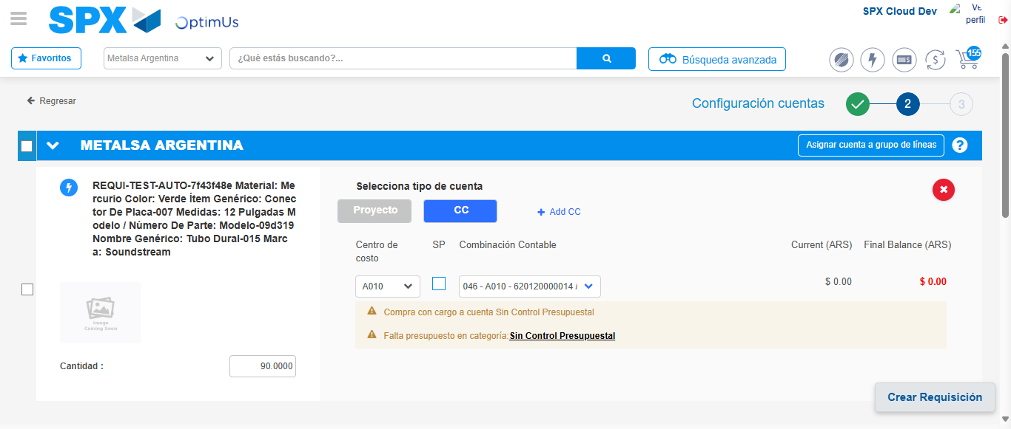Image file-name: QC_Testing-runTestMultipleTimes-nov. 28 2025, 09 59 34 a. m.

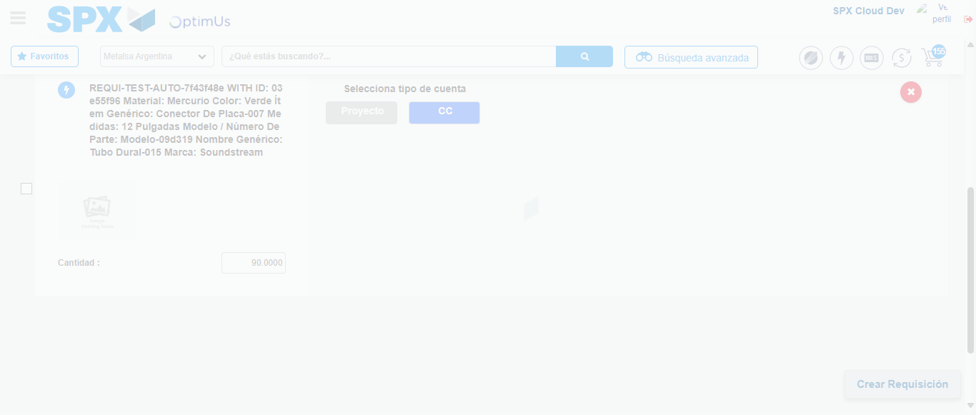Image file-name: QC_Testing-runTestMultipleTimes-nov. 28 2025, 09 59 41 a. m.

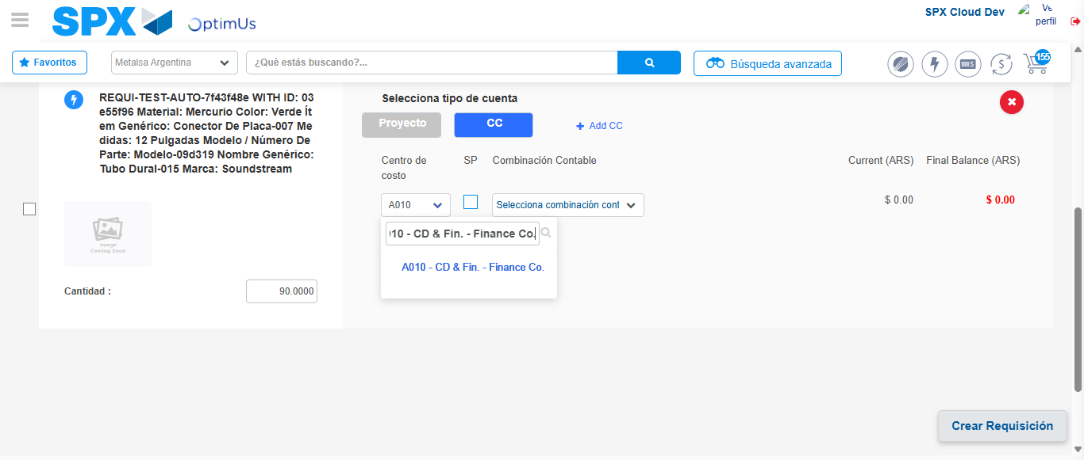Image file-name: QC_Testing-runTestMultipleTimes-nov. 28 2025, 09 59 44 a. m.

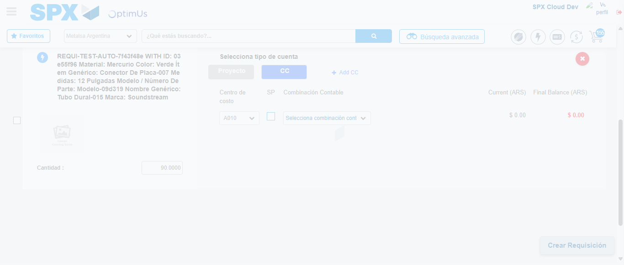Image file-name: QC_Testing-runTestMultipleTimes-nov. 28 2025, 09 59 45 a. m.

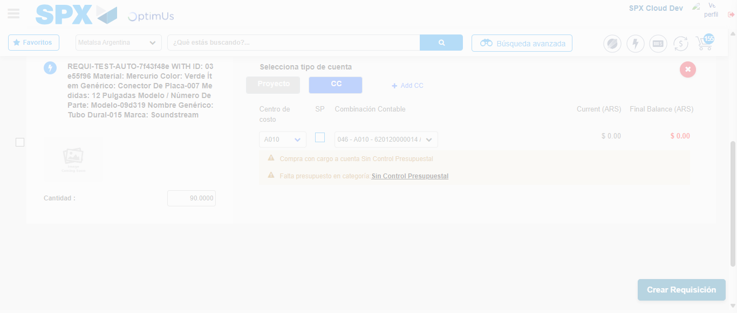Image file-name: QC_Testing-runTestMultipleTimes-nov. 28 2025, 09 59 48 a. m.

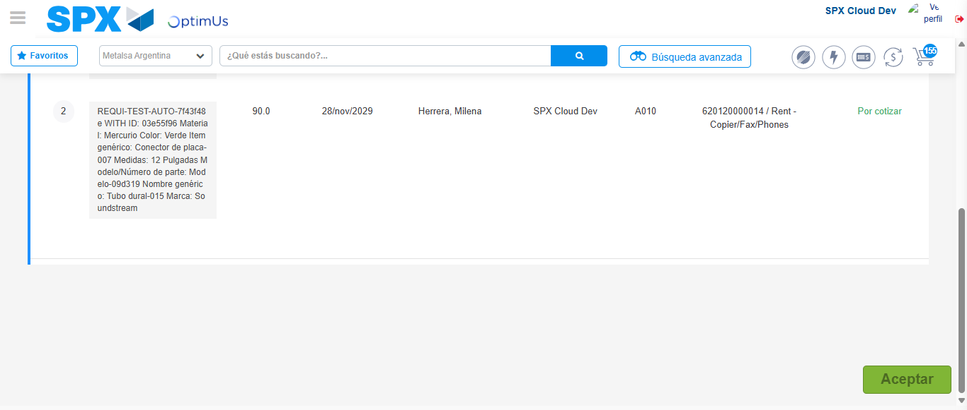Image file-name: QC_Testing-runTestMultipleTimes-nov. 28 2025, 09 59 49 a. m.

Step 7 - Accept to Requisition: Requisition Accepted
Image file-name: QC_Testing-runTestMultipleTimes-nov. 28 2025, 09 59 49 a. m.

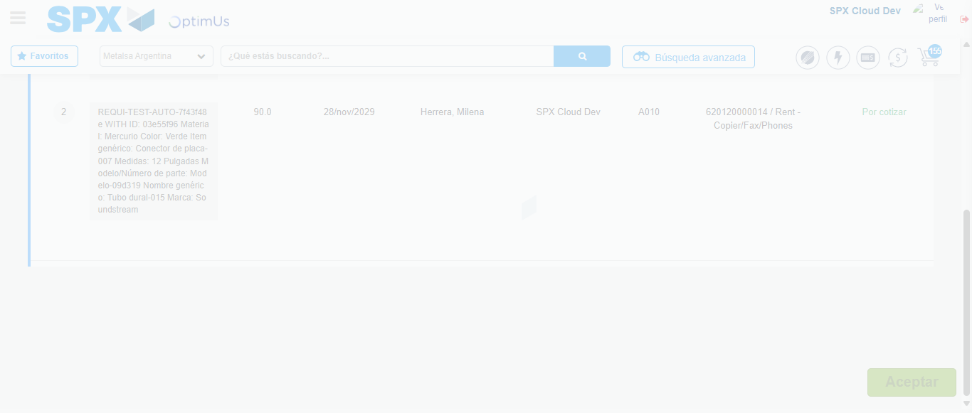Image file-name: QC_Testing-runTestMultipleTimes-nov. 28 2025, 09 59 50 a. m.

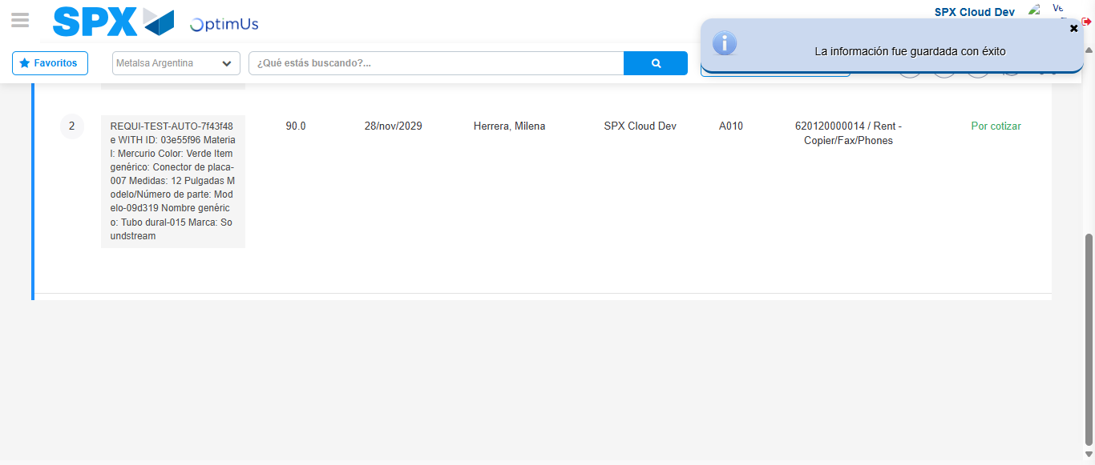Image file-name: QC_Testing-runTestMultipleTimes-nov. 28 2025, 09 59 53 a. m.

